What is Hypertension?  Hypertension (HTN) is commonly known as high blood pressure (HBP) which is a repeated high blood pressure reading. Whenever your heart contracts, it forces blood into the Arteries causing pressure against the vessel wall.  What do the numbers mean?  A blood pressure is defined by two numbers, the systolic on top and the diastolic on the bottom. The systolic number represents the pressure created when the heart contracts, diastolic represents the heart at rest.  What symptoms should I look for?  The tricky thing with high blood pressure is that at the beginning it displays with no symptoms.  The only thing you can do, is regularly monitor your blood pressure. |  | What can happen if it is not controlled?  If high blood pressure is uncontrolled over a long period, it can damage the blood vessels in your body. Damaged vessels can result in a clogging of vessels, Stroke, Heart attack, Vision loss, Sexual dysfunction, chest pain, renal failure and more. |  | 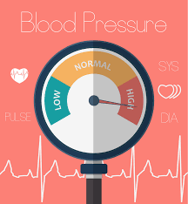
 | 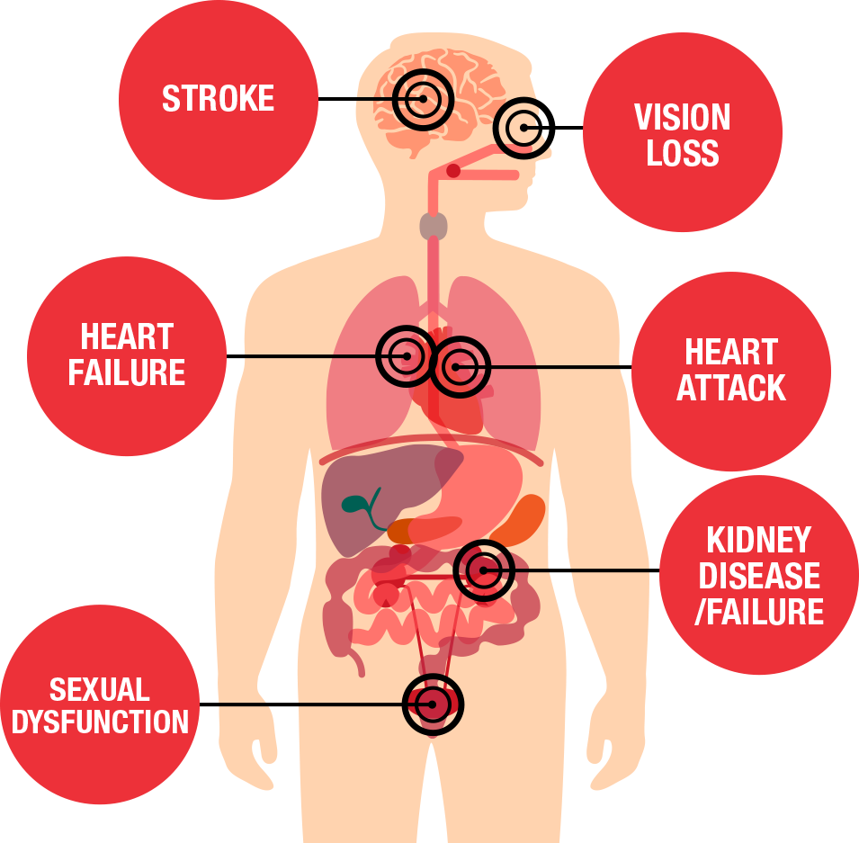

Hypertension

The Silent Killer

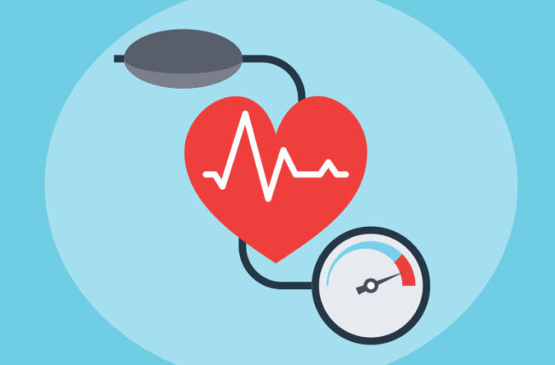 |  | So how do I monitor my Blood Pressure?  There are different ways to monitor your blood pressure, a manual cuff in combination with a stethoscope, automated cuff that goes around your wrist or bicep.  How often should I check it?  It is recommended to check your Blood Pressure daily, around the same time while sitting down and at rest.  Log does readings in a notepad, like this your provider can see trends |  | Don’t lose Heart!  - Lose Cigarettes  - Lose Junk Food  - Loosen Up and Move!
What puts me at risk to get Hypertension? |  |  |  | What to do now?
Risk factors have been identified; some you have inherited such as:  - Family history  - Male gender  - Age  - Race and Ethnicity  - Preexisting conditions (Heart/Kidney disease)  Others are modifiable:  - Obesity  - Uncontrolled Diabetes  - Cigarette smoking  - Excessive Caffeine intake  - High Cholesterol  - Diet  - Physical inactivity |  |  |  | One of the most important things to do, is to maintain a healthy lifestyle. This includes a balanced diet, a minimum of 30minutes physical activity three times a week, limted salt intake to 1500mg/day, stop smoking, increase potassium intake, remove stressors from your life and if your provider decide to start you on medication be compliant.
Classification | Systolic | Diastolic
Normal | 120 or less | 80 or less
Pre-Hypertension | 120 to 139 | 80 to 89
Stage 1 Hypertension | 140 to 159 | 90 to 99
Stage 2 Hypertension | 160 to 179 | 100 to 119
Hypertensive Emergency | 180 or more | 120 or more

